

FY B.Tech SEM I 2021-22

Engineering Physics Lab Course

# Experiment No: 7

**Title: Energy Bandgap of Semiconductor**

**Name :** Hardik Shah

**Roll No :** 16010221025

**Branch :** ETRX

**Batch :** D2

## Aim: To Determine Energy Band Gap of Semiconductor.

**Apparatus:** Container, P-N Diode, Battery, Ammeter, Voltmeter and a Thermometer

**Diagram:**

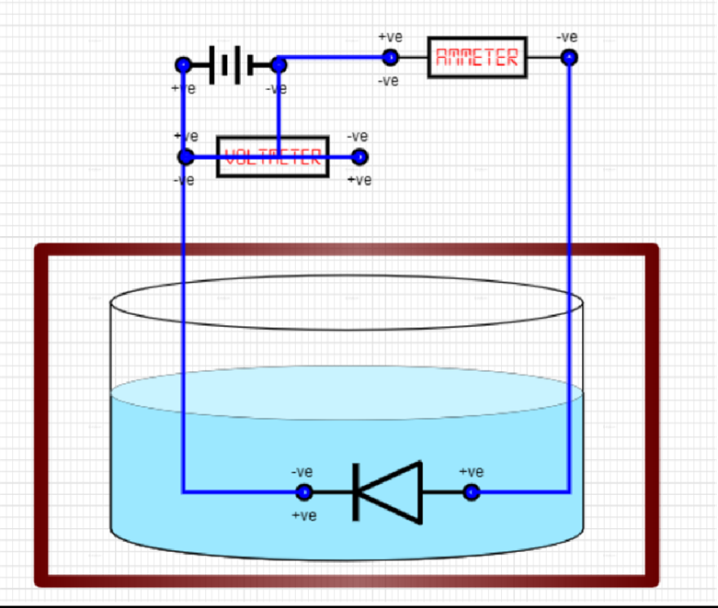

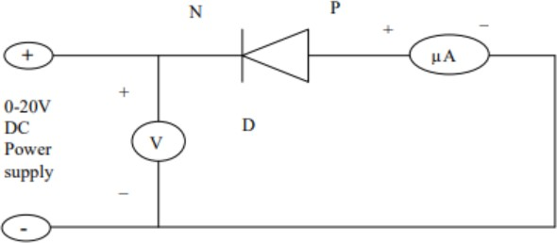

## Observation Table:

Voltage selected = 3V



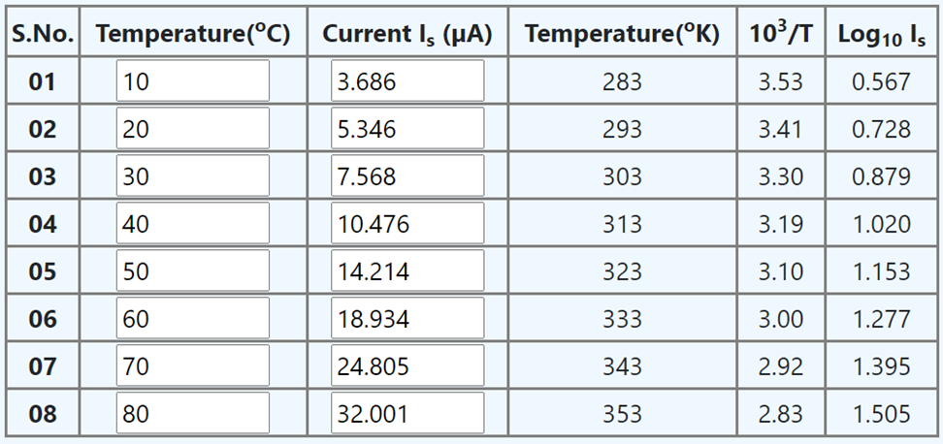

## Graph:

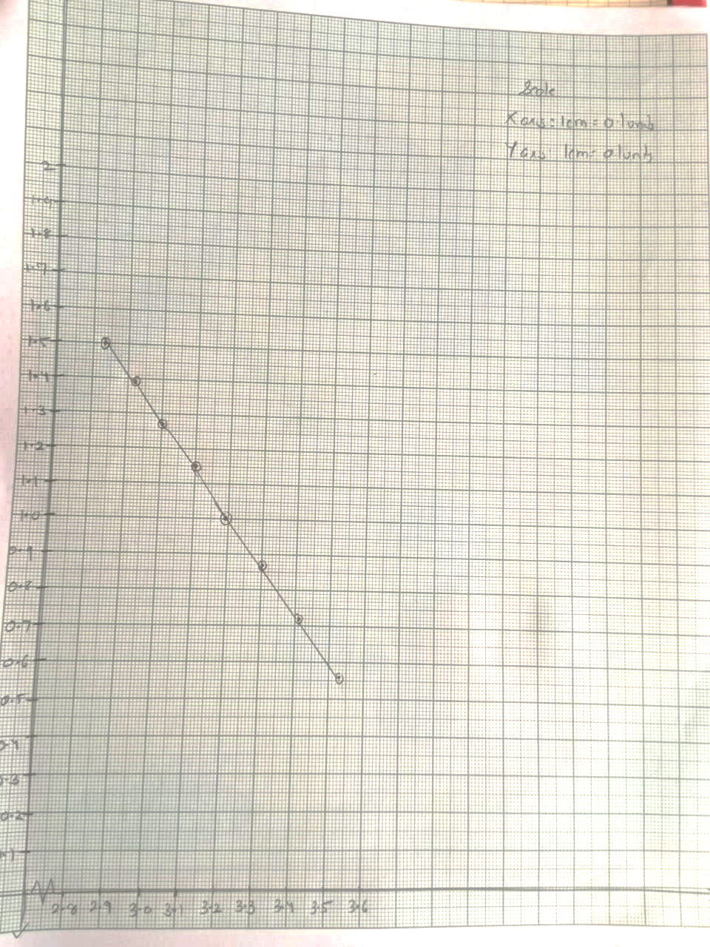

**Calculations:**



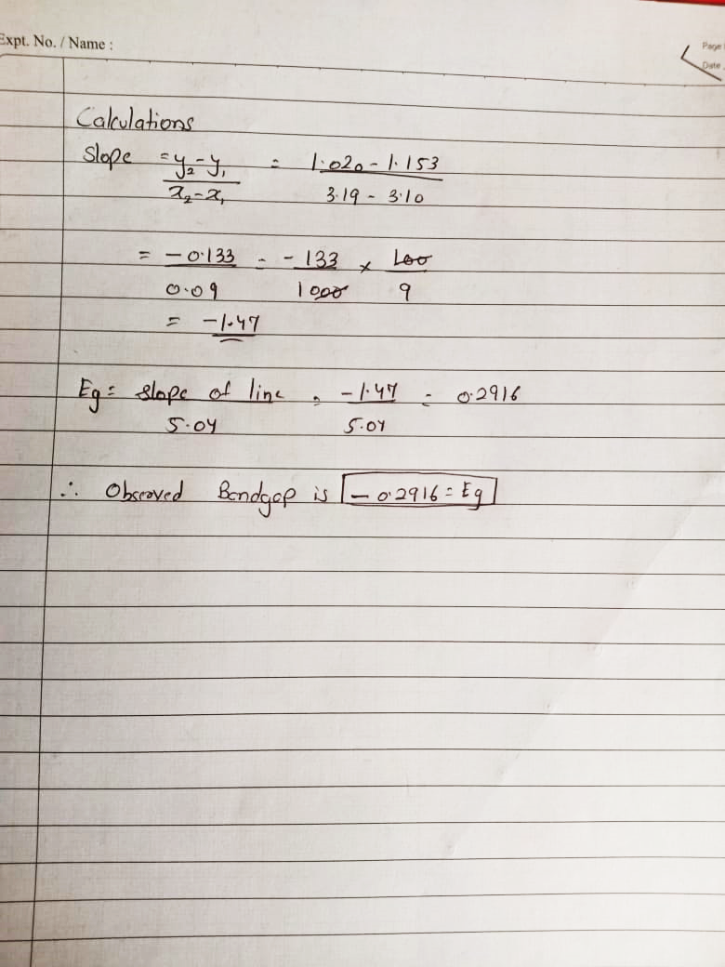

**Results and Conclusion:**

Thus, We have successfully verified and calculated the value of Energy Bandgap i.e.

**Eg= -0.2916**